Trade of Metal Fabrication
Module 2: | Thermal Processes
Unit 8: | Tungsten Arc Gas Shielded Welding (T.A.G.S)
 | Phase 2

Table of Contents
List of Figures 5
List of Tables 5
Document Release History 6
Module 2 – Thermal Processes 7
Unit 8 – Tungsten Arc Gas Shielded Welding (T.A.G.S) 7
Learning Outcome: 7
Key Learning Points: 7
Training Resources: 8
Key Learning Points Code: 8
Introduction 9
General Procedure 10
Pitfalls/Avoidance of Defects 10
Tungsten Arc Gas Shielded Welding 11
Power Source 11
A.C. Composite Equipment 11
‘Older type and newer models can be the size of a small brief case’.D.C. Composite Equipment 11
D.C. Composite Equipment 12
A.C./D.C. Composite Equipment 12
Torches 13
Tungsten Electrodes 15
Shielding Gas 16
Initiating the Arc 16
Welding Technique 17
Tungsten Inert Gas Welding 19
Principles 19
Operation 20
Choice of Current 21
Power Sources for TIG 21
Crater Filling 22
Electrodes for TIG Welding 23
Self Assessment 24
Answers to Questions 1-4. Module 2.Unit 8 26
Index 28

List of Figures
Figure 1 - Basic Principle of Tungsten Arc Gas-Shielded Welding 8
Figure 2 - A Typical Air-Cooled Torch 12
Figure 3 - A Typical Water-Cooled Torch 12
Figure 4 - Hot-Wire TAGS Welding, an Automatic Variation of the Process 13
Figure 5 - Various Types of Nozzle 13
Figure 6 - Preparation of Tungsten Electrodes (Approximate Dimensions) 14
Figure 7 - Flowmeter and Gas Economiser 14
Figure 8 - TAGS Welding of Mild Steel Sheet in the Flat Position 16
Figure 9 - Principles 18
Figure 10 - Arc Length - Controls Weld Width 19
Figure 11 - Operation 19
Figure 12 - Crater Filling 21

List of Tables
Table 1 - Electrodes for TIG Welding 22

Document Release History
Date | Version | Comments
01/11/06 | First draft
05/12/06 | Implemented edits from Kenny.
13/12/13 | SOLAS transfer

Module 2 – Thermal Processes

Unit 8 – Tungsten Arc Gas Shielded Welding (T.A.G.S)
Duration – 9 Hours

Learning Outcome:
By the end of this unit each apprentice will be able to:
- Safely set up and weld using a TIG/TAG welding plant
- State the difference between zirchoniated and thoriated tungsten electrodes and their uses (power sources)
- Describe the advantages/disadvantages of the TIG/TAG process
- State the safety precautions to be observed when using TIG welding plant
- Weld a series of exercises

Key Learning Points:
Rk | Describe the process of TIG/TAG welding.
Rk | Describe the components of TIG/TAGs welding plant (air cooled/water cooled foot switch).
Sc Rk | Types of gases used and their applications.
Rk | Types of electrodes and their uses.
Sk | Grinding of electrodes and their care (contamination).
Sk | Starting an arc – high frequency and scratch start.
Sk | Welding techniques – pre heating/post heating.
Rk | Types of power source – AC and DC.
Rk | Advantages and disadvantages of TIG/TAG’s process.
Rk H | Safety procedures and precautions – equipment, work area, P.P.E.
Sk | Torch position when welding.
Rk Sk | Identification of faults on plant/avoidance of defects.
P | Communication, safety awareness.

Training Resources:
- Fabrication workshop facilities
- T.A.G.s welding plant and equipment
- Filler rods
- Welding booths and extractors
- Handout notes
- Safety clothing and equipment
- Material as stated in exercise
- Examples of good and bad welds

Key Learning Points Code:
M = Maths D= Drawing RK = Related Knowledge Sc = Science
P = Personal Skills Sk = Skill H = Hazards

Introduction
Welding of aluminium and magnesium had always been a problem with conventional manual metal arc and oxyacetylene processes. Corrosive fluxes had to be used to remove the oxide film from the material surface and molten pool.
To overcome this problem, and to eliminate atmospheric contamination during welding, inert gas was first employed as a shield in the early 1930s.
The first gas-shielded process used a tungsten electrode and helium shielding gas. It was called the tungsten inert gas (TIG) process. Direct current with electrode positive was used. With this system, the tungsten electrode tended to overheat and transfer fragments of tungsten to the weld unless a low current was utilised.
It was found that overheating could be avoided by making the tungsten electrode negative. This made the process suitable for welding stainless steel but unsuitable for aluminium and magnesium.
The development that allowed these materials to be welded was the use of alternating current, with a high-frequency, high-voltage current superimposed over the basic welding current to stabilise the arc. Using a.c. gives the perfect answer for welding aluminium and magnesium. When the electrode is positive, a cleaning action takes place on the surface of the weld and plate area; particles of oxide are lifted up electrically, leaving an oxide-free area. On the next half-cycle, the electrode becomes negative, allowing it to cool slightly and preventing overheating. As the cycle repeats, the alternating current gives the perfect balance of oxide removal and electrode cooling; the inert gas shield prevents further contamination until the molten pool has solidified.
The process can be called TIG (tungsten inert gas) or TAGS (tungsten arc gas-shielded) welding. In these notes TAGS is used, as the term also covers the use of gas shields that may not be strictly inert.
TAGS welding uses an inert (non-reactive) gas shield, usually argon or helium, to surround a non-consumable tungsten electrode, thus protecting the electrode and molten pool area from the atmosphere. This means that welding can be carried out without the need for a chemical flux.
The welding heat is created by an electric arc formed between the end of the tungsten electrode and the work. Tungsten is used as the electrode because it has a very high melting point (about 3400°C).
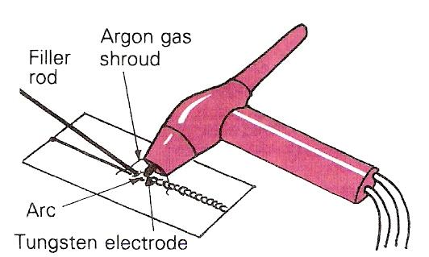
Figure 1 - Basic Principle of Tungsten Arc Gas-Shielded Welding

General Procedure

Pitfalls/Avoidance of Defects
The following general instructions which are not repeated later in the text apply to Tungsten-Arc Gas Shielded Welding.

Equipment, particularly composite power sources, vary considerably in their control arrangements.

Always -
- Comply with the prescribed safety precautions and fire-prevention procedure.
- Check that return lead is firmly connected to bench and power source.
- Check that all connections to torch hose assembly are in good order.
- Check that argon and water hoses are not 'kinked' or otherwise obstructed.
- Check that power source is switched on.
- Check that argon cylinder valve is open.
- Check regulator.

- Check that correct size gas nozzle is fitted to torch.
- Check that the tungsten electrode is of the correct type and size, that it is in a clean and properly prepared condition.
- Check that the electrode extension is correct for the work to be done.
- Check that the argon flow is correctly set. The flow rate should be checked with the torch removed from the hook on the gas economiser, or with the gas purge button depressed on a composite power source.
- Check that the gas delay and gas purge times are correctly set when using composite power source.
- Check that power supply to separate high-frequency unit is switched on.

Tungsten Arc Gas Shielded Welding

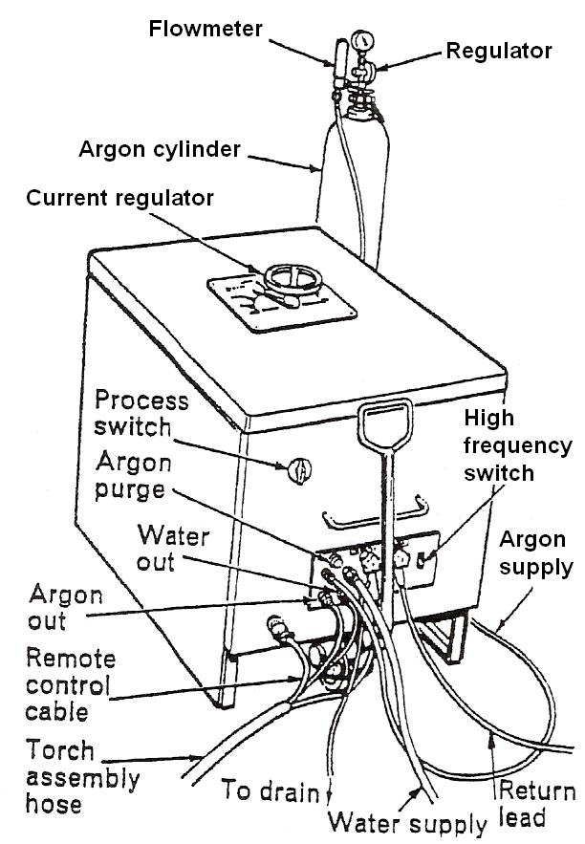
Power Source
These are classified into two broad groups:
Alternating Current (A.C.) or Direct Current (D.C.) according to the output current. Sizes vary from 3 to 400 amperes output.
A.C. is used for welding aluminium, magnesium, alloys based on these metals and aluminium bronzes.
D.C. is used for welding mild steel, alloy steels including stainless steel, copper, copper alloys, nickel, nickel alloys, titanium and other rare and reactive metals.

A.C. Composite Equipment
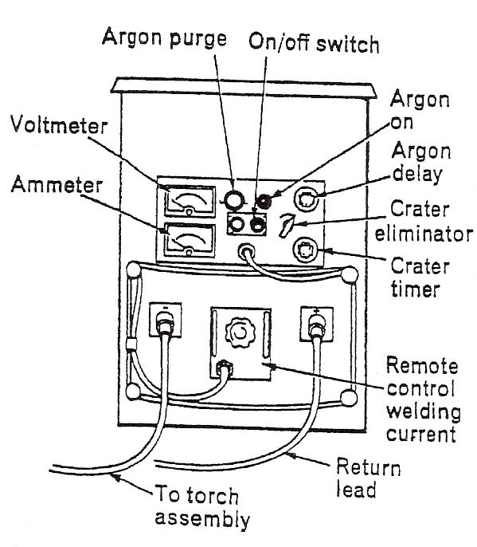
Usually single-phase transformers, either air or oil cooled.
The built-in auxiliaries usually include:
- Remote-controlled contactor to enable the operator to switch the welding current on or off.
- Capacitors to suppress the D.C. component produced in the welding circuit.
- A high-frequency unit or a combined h.f. and voltage surge injector to initiate and maintain the arc.
- Solenoids to control gas and water flows.
(In many cases a switch is provided to enable the power source to be used for manual metal-arc welding).

‘Older type and newer models can be the size of a small brief case’.

D.C. Composite Equipment
Usually three-phased rectifier units comprising:

- Transformer.
- Rectifier bank.
- Remote-controlled contactor.
- Spark starter to initiate the arc.
- Solenoids to control gas and water supplies.
- Sometimes, remote control of welding current.

(In many cases a switch is provided to enable the power source to be used for manual metal-arc welding with D.C.)

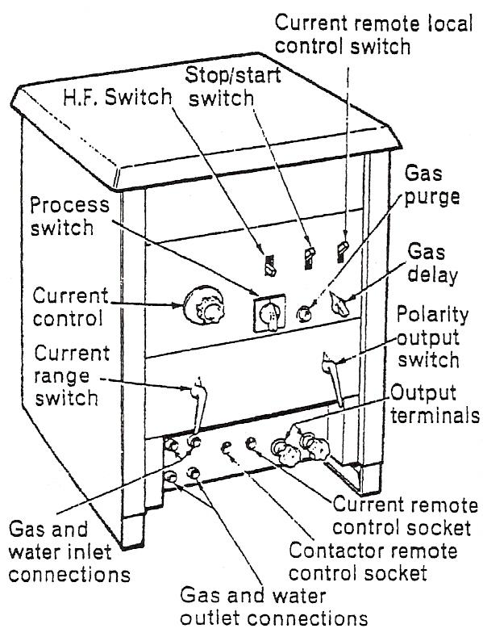
A.C./D.C. Composite Equipment
Single-phase transformer rectifiers can provide either an A.C. or D.C. output as required.
These power sources usually include automatic high-frequency sources for both A.C. and D.C. welding, together with the usual auxiliaries.
(In many cases a switch is provided to enable the power source to be used for manual metal-arc welding with A.C. or D.C.).
Note:
Power sources used for manual metal-arc welding can be adapted for this process if additional features are added to the circuit.
It is better to use a composite power source specially designed for tungsten-arc gas shielded welding, that can be switched subsequently for use in manual metal-arc welding.

Torches
There are many designs available, but they all fall into two main categories.
The lighter air-cooled torches are made for welding thinner sheet sections (Figure 2). They are usually in three sizes - up to 50 amps capacity, 75 amps capacity or 100 amps capacity - but these ratings can vary with different makes.
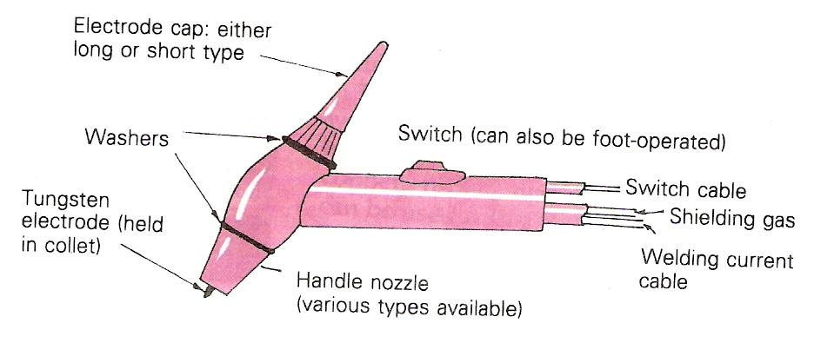
Figure 2 - A Typical Air-Cooled Torch

Water-cooled torches are designed for more heavy-duty welding of thicknesses up to approximately 12 mm (Figure 3). They can have current capacities from 100 to 500 amps. They usually incorporate a fuse system to cut off the current supply and to save damage to the equipment should there be a water supply failure.
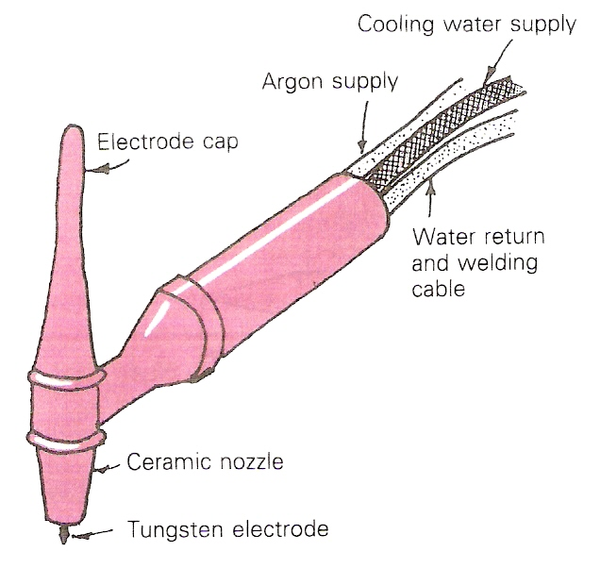
Figure 3 - A Typical Water-Cooled Torch

Figure 4 shows an automatic variation of the TAGS process.
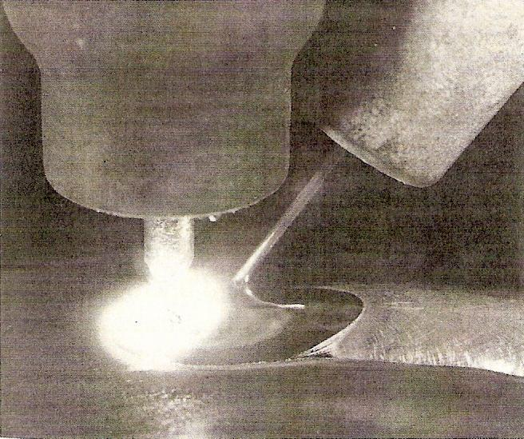
Figure 4 - Hot-Wire TAGS Welding, an Automatic Variation of the Process

A foot or hand control unit (on the torch) can be used for gradually reducing the current towards the end of a weld run. This allows the build-up and elimination of the end crater while maintaining the protection of the argon gas shield.
Ceramic nozzles are used with both the air and water-cooled torches up to about 200 amps. However, above this amperage, metal nozzles with water cooling should be used.
Various shapes and sizes of nozzle are available to suit all ranges of work (Figure 5). These include shorter nozzles for working in confined spaces, transparent nozzles for improved visibility, and extended nozzles for welding in deep recesses.
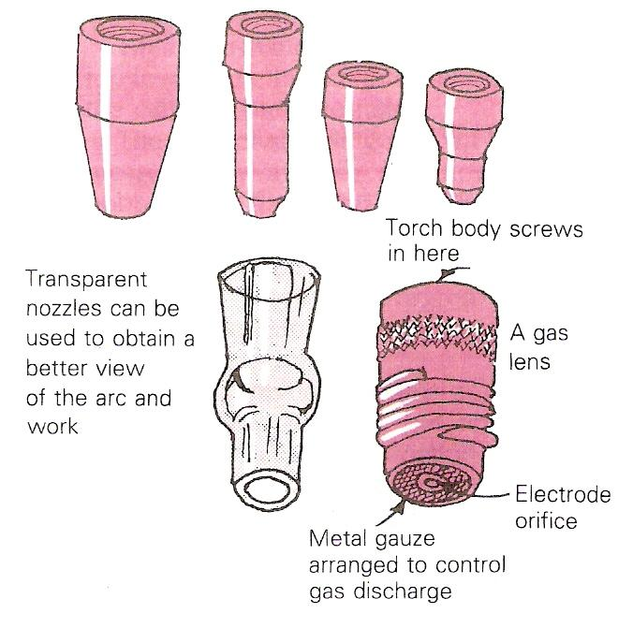
Figure 5 - Various Types of Nozzle

Gas nozzles are not particularly strong and the effect of constantly being heated and then cooled can make them brittle. You should therefore handle them with care in order to obtain maximum usage.

Tungsten Electrodes
To improve the quality of tungsten electrodes, certain additions can be made during manufacture. The main elements added are either zirconium or thorium. These help to reduce tungsten inclusions in the weld, which increases the current-carrying capacity and the life of the electrode while also giving improved arc stability.
Thoriated electrodes are used mainly for d.c. welding with electrode negative for stainless and heat-resisting steels, mild and low alloy steels, copper, nickel, titanium and other metals. They can be used with a.c., but this is not recommended for aluminium and its alloys, as zirconiated electrodes give better arc characteristics with these materials.
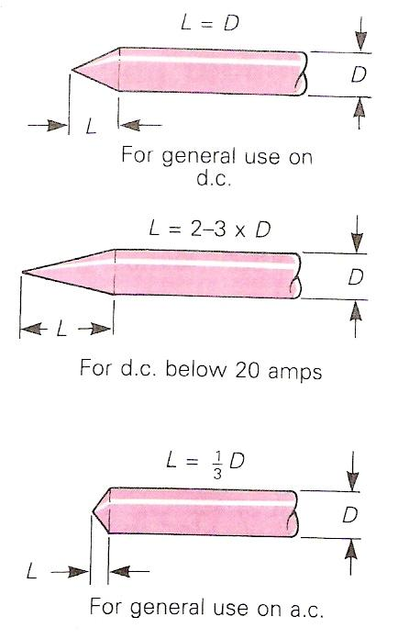
Figure 6 - Preparation of Tungsten Electrodes (Approximate Dimensions)

Zirconiated electrodes have been specially designed for use on a.c. welding and are not as efficient on d.c. Zirconium electrodes are especially suitable for welding of aluminium, magnesium and their alloys.
Tungsten electrodes are prepared for use by grinding to the required shape. Figure 6 shows approximate dimensions.
Always use localised dust extraction when grinding tungstens.
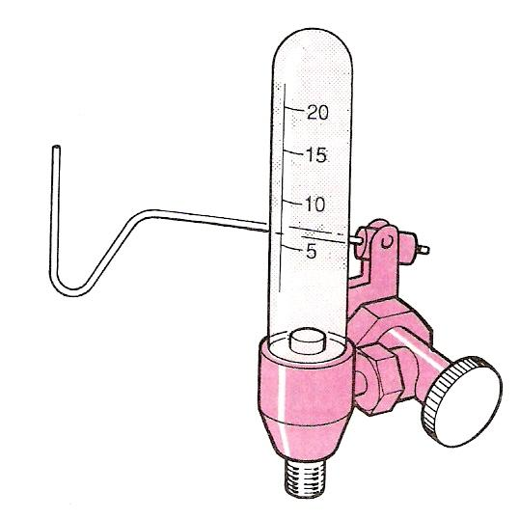
Figure 7 - Flowmeter and Gas Economiser

Shielding Gas
Welding-grade argon is supplied in steel cylinders painted light blue. The usual size of cylinder is 8.5 m³ charged at a pressure of 172 bar (2500 lbf/m²).

Take care that the cylinder pressure does not fall too low, as the moisture level of the gas can rise as the cylinder pressure falls.

The flow of shielding gas can be controlled and measured by a valve and flowmeter. A simple bobbin-type flowmeter is shown in Figure 7. This type is also fitted with a gas economiser, similar to the type used in oxyacetylene welding. It has a lever (the contactor) on which the TAGS torch can be hung, to stop the flow of shielding gas.

Some equipment contains automatic flow controls for both shielding gas and water cooling. They can operate in conjunction with the contactor and allow argon to flow for a preset duration before and after welding.

Initiating the Arc
When TAGS welding was first developed, the simplest way to start the arc was to touch the tungsten electrode to the workpiece. This caused the current to begin to flow. The electrode was then simply raised until the required arc length was obtained for the particular welding application.

This method was called touch or scratch starting. Instead of striking the arc directly on to the workpiece and risking electrode contamination, a carbon block was used. The carbon block was placed near the start of the weld. Once the arc was established on the block, it could be moved down the side of the block to the workpiece.

The development of special arc-starting circuits eliminated the need for touch starting and the problems of tungsten contamination.

Welding Technique
This section gives an example procedure for welding 1.5 mm thick mild steel plate.
Use a filler rod complying with British Standard 2901 A15. Set the argon flow to 5.6 litres/minute. Set the welding current in the range of 60-75 amps.
- Hold the torch between the forefinger and thumb of the right hand. The handle of the torch should lie on the top of the hand hose assembly should be supported by forearm.
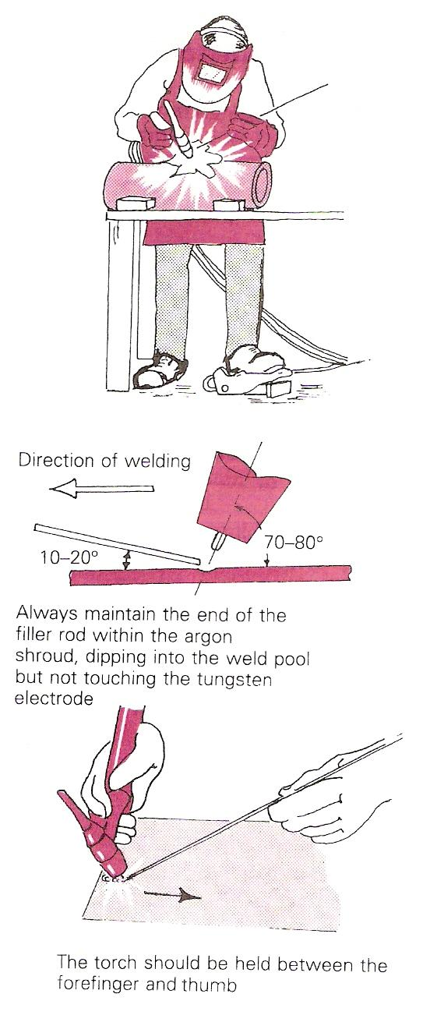
Figure 8 - TAGS Welding of Mild Steel Sheet in the Flat Position

- Lower the torch at an angle of about 70-80° until it is about 25 mm from the sheet surface at the right-hand end. With the welding current on, allow the argon to purge the hose of air and switch on the high-frequency start.
- Position the welding shield and lower the torch gently towards the sheet. As the tungsten gets close to the sheet, a train of high-frequency sparks will initiate the arc and the high frequency will cut out.
- Lower the torch to maintain an arc length of about 1.5 mm.
- Once the molten pool has been formed, the technique is very similar to gas welding. Hold the filler rod in the left hand between the fingers and thumb, and feed it into the molten pool at an angle of approximately 10-20° (Figure 8).
- Always keep the end of the filler rod within the argon shroud, making contact with the weld pool but not touching the electrode.
- If the filler touches the electrode, or the electrode touches the work, it can be contaminated and will have to be reground to shape.

As with gas welding, practise producing neat straight beads of weld on scrap plate before you attempt to join two pieces of plate together.

Tungsten Inert Gas Welding

Principles
Tungsten inert gas shielded welding is usually called TIG welding. It uses an arc between a tungsten electrode and the work to fuse the joint. The electrode is not melted and any filler metal needed to build up the weld profile is added separately.
Both the molten metal in the weld pool, the tip of the filler wire and the hot electrode are protected from atmospheric contamination by a shield of inert gas. Usually the gas is argon, but helium by itself or mixed with argon may be used for special applications. Argon - hydrogen mixtures can be used for stainless steel.
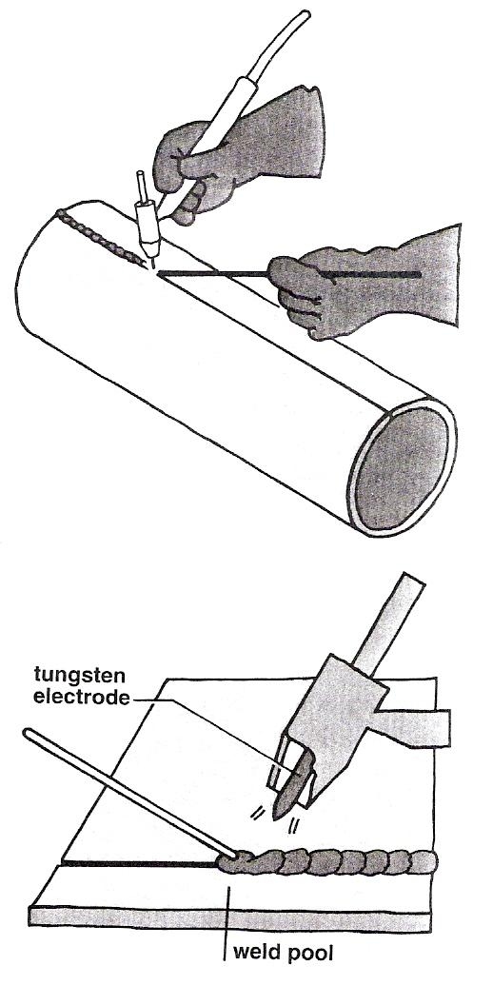
Figure 9 - Principles

Operation
TIG welding is suitable for both manual and mechanised welding.
In manual welding, the operator points the electrode in the direction of welding and uses the arc to melt the metal at the joint.
If filler metal is required, for example when making a fillet weld, it is added to the leading edge of the weld pool.
Filler is supplied as cut lengths of wire - usually 1 metre long.
Arc length is controlled by the welder and is usually between 2mm and 5mm.
Heat input to the arc depends on the current chosen by the operator.
Travel speed is adjusted to match the time needed to melt the joint.
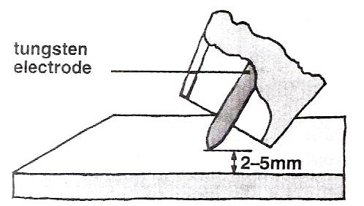
Figure 10 - Arc Length - Controls Weld Width

Using an arc starting device enables the arc to be struck without touching the electrode to the work.
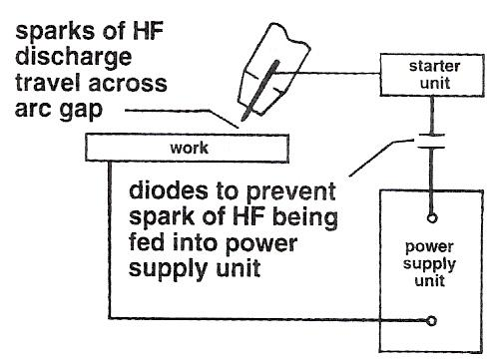
Figure 11 - Operation

Choice of Current
Both direct current (dc) and alternating current (ac) can be used with TIG welding.
Direct current with the electrode connected to the negative terminal of the power source is used for:
- carbon steels
- copper and its alloys
- stainless steels
- nickel and its alloys
- titanium and its alloys
- zirconium and its alloys

Alternating current is used for welding:
- aluminium and its alloys
- magnesium and its alloys
- aluminium bronze

Power Sources for TIG
Power sources for use with TIG welding must be capable of delivering a constant current at a preset value. They are often called 'drooping characteristic' units.
Rectifier units are commonly used for dc welding although motor generators may be more suitable for site use.
Single phase transformer units are almost universally used for welding aluminium. Modern power sources have square waveform.
Combined ac/dc power sources can be used where there is a mix of work.
Modern power sources combine constant current and constant voltage (cc/cv) and are called inverters.
The power source should be equipped with:
- foot operated on/off switch
- remote control for the current
- crater filling device
- an arc starting device
- gas control valves
- water control valves - for nozzle cooling at high currents.

Crater Filling
Automatic gradual reduction of the current at the end of a weld run avoids the formation of a crater.
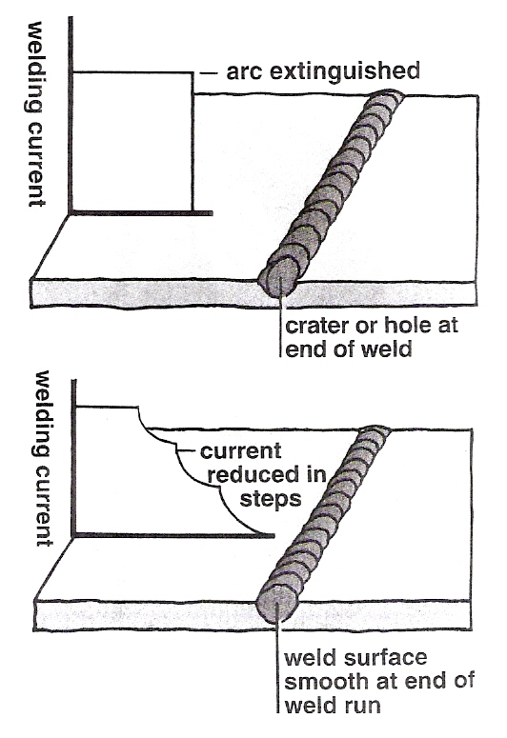
Figure 12 - Crater Filling

Electrodes for TIG Welding
Pure tungsten electrodes can be used for TIG welding. Thoriated and zirconiated types give easier starting and better arc stability and are generally preferred.
Thoriated tungsten electrodes contain 2% thoria (thorium oxide) and are used for dc welding.
Zirconiated tungsten electrodes contain 2% zirconia (zirconium oxide) and are recommended for ac welding of aluminium.
The diameter of the electrode is chosen to match the current. The minimum current depends on arc stability.
The maximum current a given diameter of electrode can carry is determined by the onset of overheating and melting.

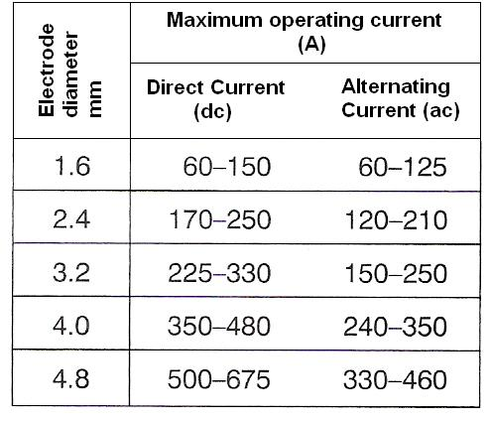
Table 1 - Electrodes for TIG Welding

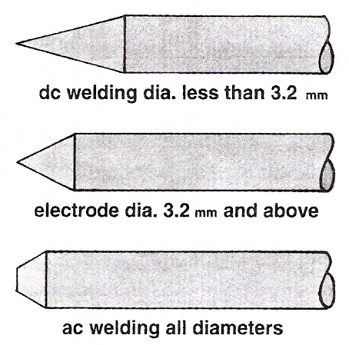
Before use, the end of the electrode is ground on a silicon carbide wheel to give the most appropriate profile. Contamination with other metals must be avoided as this lowers the melting point of the electrode.

For dc welding a sharp point is required.

For ac welding only a small bevel is needed as the end of the electrode becomes rounded when the arc is operated.

Self Assessment

Questions on Background Notes – Module 2.Unit 8

1. What does the abbreviation T.I.G stand for in relation to welding?

2. Name the two types of power sources used in T.I.G / T.A.G welding and
give an example of each as to which power source complements different
materials.

- With the aid of a diagram sketch a T.I.G Torch and clearly show the following:

  - Back-Stop or Electrode Cap
  - Collette

4. List two types of Tungsten Electrodes.

Answers to Questions 1-4. Module 2.Unit 8
1.

Tungsten Inert Gas

2.

Direct Current:

Direct Current with the electrode connected to the negative
Terminal of the power source is used for:

- Carbon Steel
- Copper and its alloys
- Stainless Steel
- Nickel and its alloys
- Titanium and its alloys
- Zirconium

Alternating Current:

Alternating Current is used for welding:

- Aluminium and its alloys
- Magnesium and its alloys
- Aluminium Bronze

3.

Figure 19. T.I.G Torch

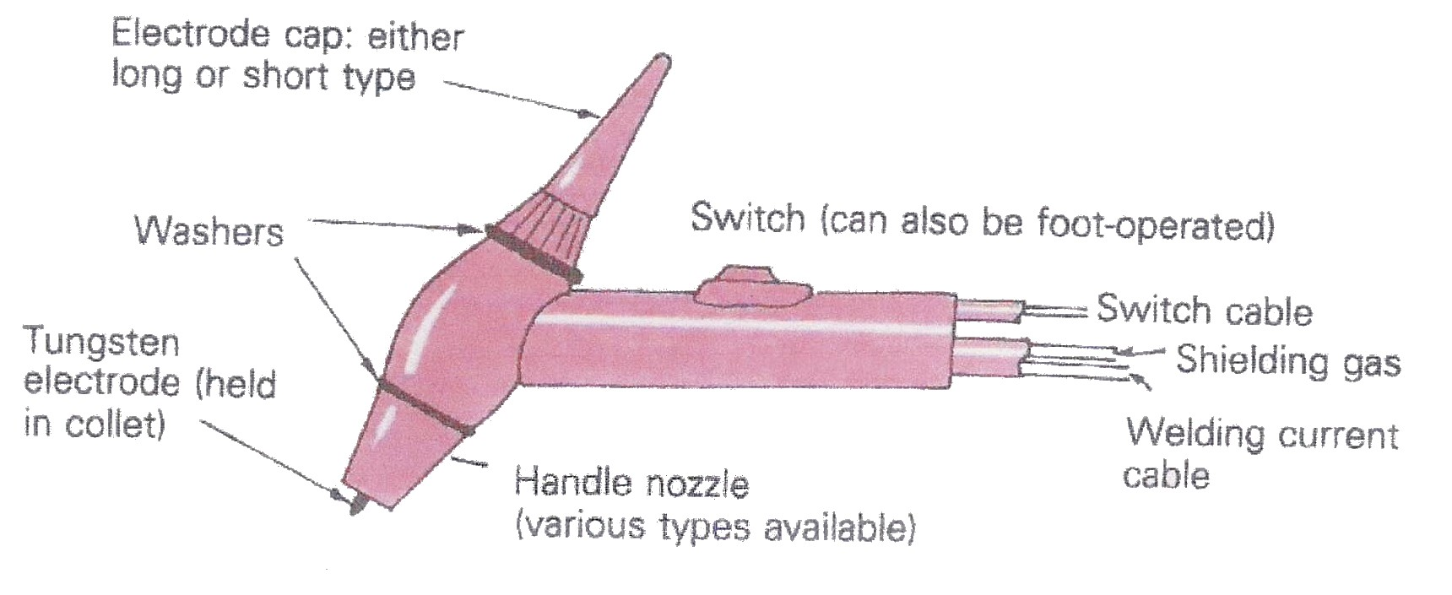

4.

Electrodes for T.I.G Welding:

- Pure Tungsten
- Thoriated Tungsten
- Zirconiated Tungsten

Index

G
General Procedure, 9
Pitfalls/Avoidance of Defects, 9
I
Introduction, 8
P
Power Source
A.C. Composite Equipment, 10
A.C./D.C. Composite Equipment, 11
D.C. Composite Equipment, 11
Power Sources for TIG
Crater Filling, 21
T
Tungsten Arc Gas Shielded Welding, 10
Initiating the Arc, 15
Power Source, 10
Shielding Gas, 15
Torches, 12
Tungsten Electrodes, 14
Welding Technique, 16
Tungsten Inert Gas Welding, 18
Choice of Current, 20
Electrodes for TIG Welding, 22
Operation, 19
Power Sources for TIG, 20
Principles, 18

